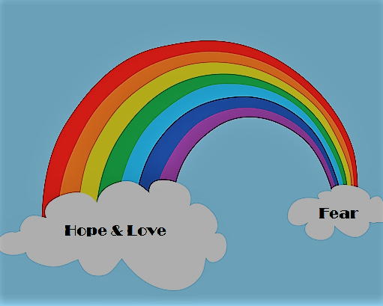
Rainbow Baby Advisor/Doula Curriculum Topics
This new certification program will be offered beginning in September, 2017

The following topics will be covered during this class. Prerequisite readings and videos required.

Topics
Teaching care givers the whats, whys and hows
- What families go through
- Why they feel the way they do
- How to specifically support them in areas such as the following:
- Deciding/Trying to get pregnant again
Infertility
Higher risk
Fears, worries and anxieties
Love, hope and attitudes
Timing of pregnancy
Replacing baby? Bonding issues
Potential bonding issues and ways to promote positive bonding (protecting vs empowering)
Shifting the mindset, reframing the Pregnancy and potential outcomes
Understanding feelings and emotions during the pregnancy
Feel it to heal it
Love yourself
Self-harm or hurting others
Intentions in caring –
Offer ideas as options and invitation (not statemetns that can be perceived as demands)
Birth plans and preparations
Children now and later
The birth, postpartum and parenting beyond
Naming
Parenting a live baby and a baby who has died
Answering tough questions
Family & friends
And much more…

